Document A

Work for You at Your Distilling House

(Transcription is modified for length and clarity.)
Ship captain and merchant Richard Derby owned a rum distillery in Salem. Another Salem colonist, Samuel Fisk, enslaved a man who worked at Derby’s distillery in 1762 and 1763. Fisk may have “rented out” the man he enslaved. He wrote this invoice for money owed to him by Derby for one year of the enslaved man’s labor.

Salem June 23, 1763

Captain Richard Derby to Samuel Fisk

To my Negro man’s work for you at your distilling house
From March 18, 1762, to March 10, 1763

(1762) £ S
To his work in March: 19 Days at 3 shillings a day . . 1.. 16
April: 25 days . . . . . . 3.. 15
May: 24 days . . . . . . 3.. 12
June: 24 days . . . . . . 3.. 12
July: 23 days . . . . . . 3.. 9
August: 26 days . . . . . . 3.. 18
September: 25 days . . . . . . 3.. 15
October: 25 days . . . . . . 3.. 15
November: 26 days . . . . . . 3.. 18
December: 27 days . . . . . . 4.. 1
1763
January: 26 days . . . . . . 3.. 18
February: 23 days . . . . . . 3.. 9
March: 9 days . . . . . . 1.. 7
295 Lawful money 44.. 5_

Errors Excepted Samuel Fisk

Vocabulary
- £ and S: symbols for Pounds and Shillings, English currency (money). 20 S is equal to 1 £.

Document B
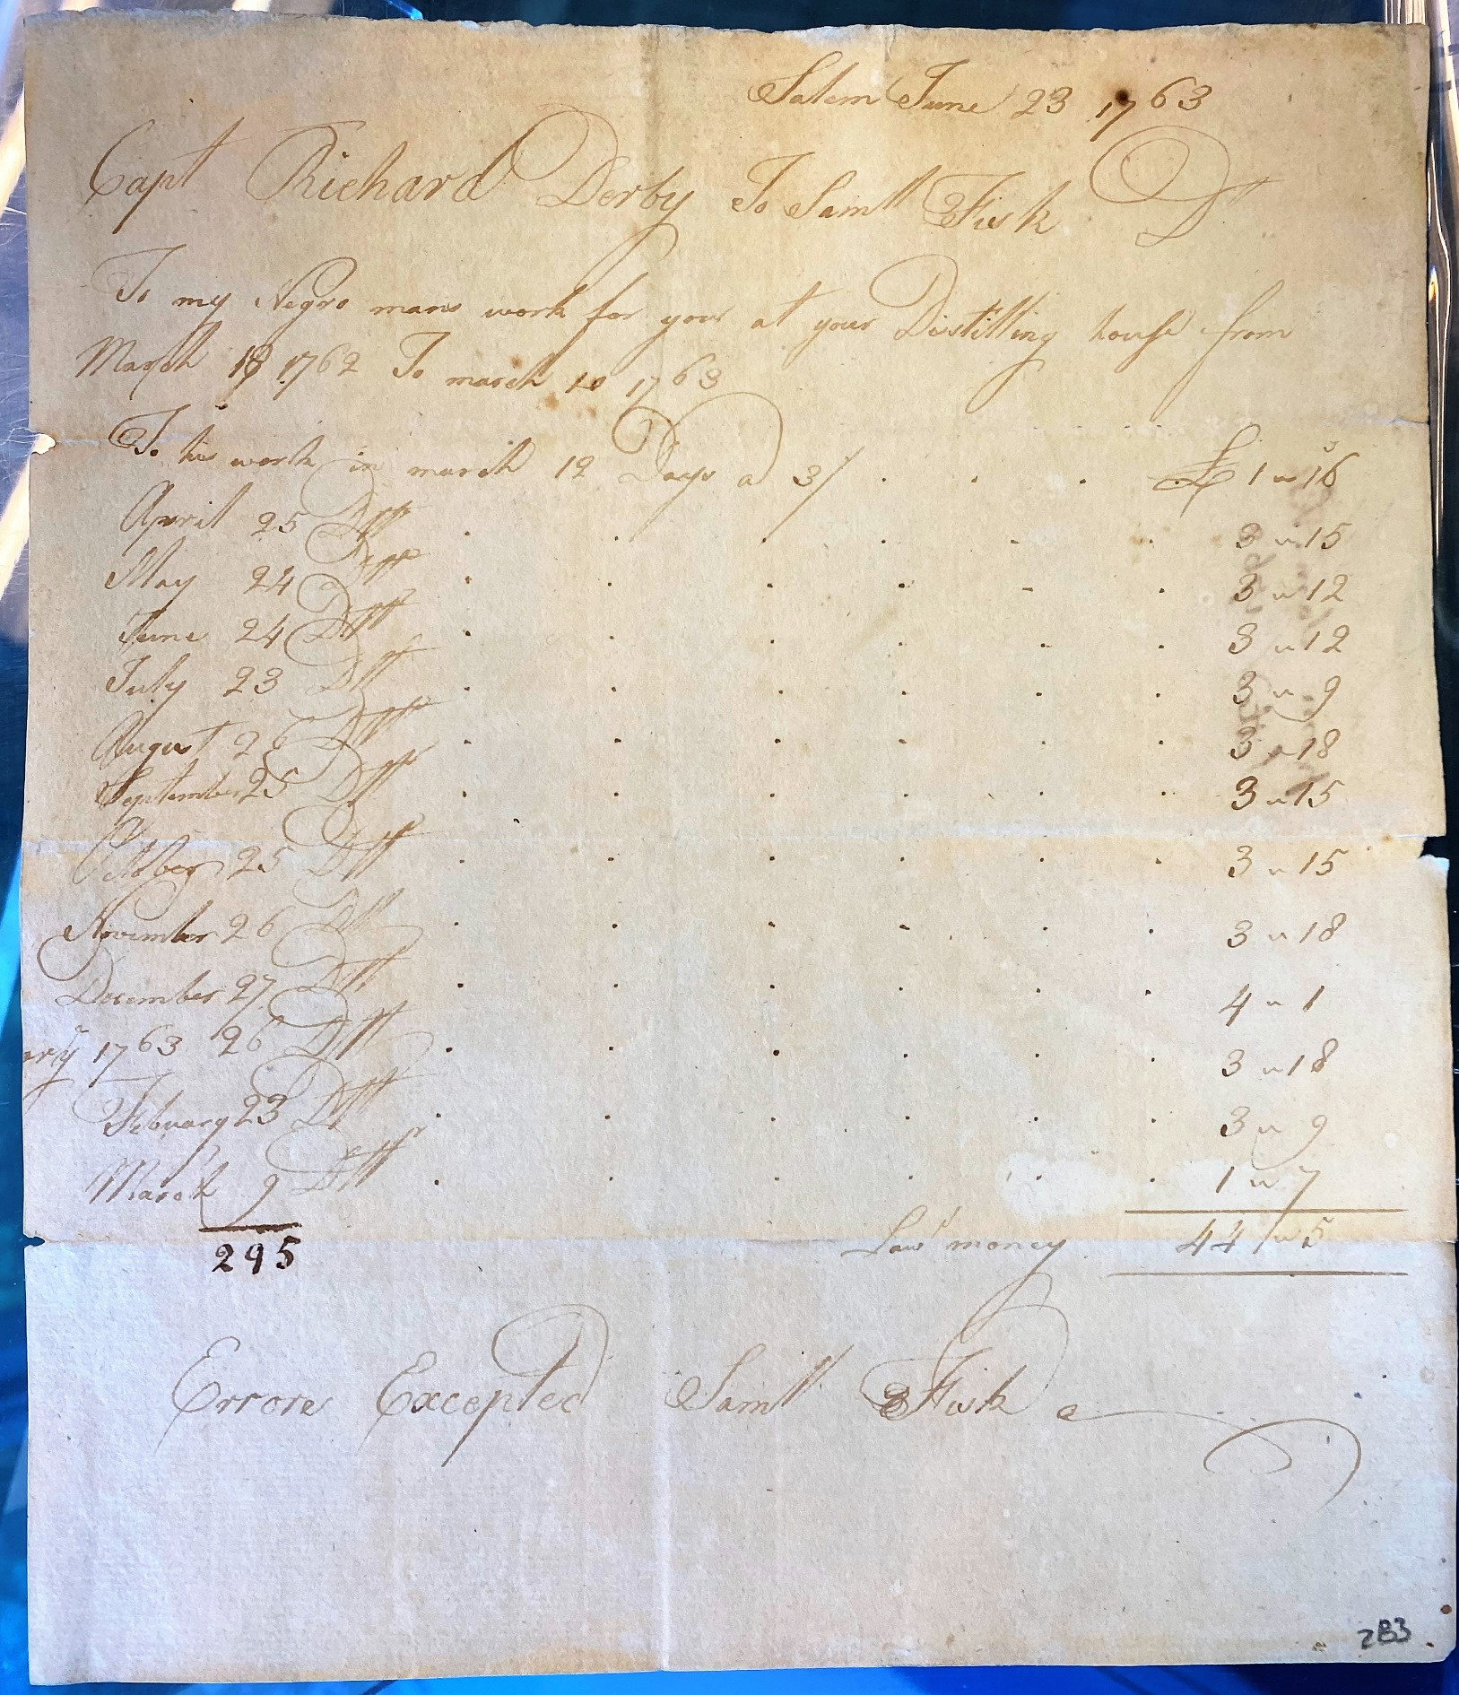

Image Source
Derby Family Papers, MSS 37, Box 14, Folder 9
Courtesy of The Phillips Library, Peabody Essex Museum, Salem, Mass

Document B

Marriage of Jane and Isaac
(Transcription is modified for length and clarity.)
Jane was a Salem woman enslaved by Captain Richard Derby. She married Isaac, a man enslaved by Samuel Gardner, in 1754. Their marriage is recorded in the free, online database, “Early Vital Records of Massachusetts.” The database holds information collected from church records, town records, private records, gravestone inscriptions, and newspaper articles from across Massachusetts.
This page documents the marriages of free and enslaved Black people (in Salem) whose names started with the letter “J.” The records span from 1747 – 1845. Jane and Isaac are both identified as “servants.” This word was a euphemism (or substitute) to describe African people who were enslaved.

SALEM MARRIAGES
…
…
…
Jane, servant of Captain Richard Derby, and Isaac, servant of Samuel Gardner, Jan. 23, 1754
Jane [servant of George Small of Danvers], and Primus [servant of Hon. B. Lynde], at Danvers, Dec. 30, 1757.
Jane [servant of Daniel Mackey], and Jack [lately a servant of Nathaniel Archer, deceased], certified Feb. 5, 1775.
Jane, belonging to widow Lois Lee, and Cesar Harvey, belonging to Jos. Dowse. Oct. 17, 1778.
Janes, Flora, and Charles Hower. March 11, 1815.
Jenny, servant of Richard Ward, and Milo, servant of William Pool, of Danvers, deceased. April 20, 1776.
Jarret, Ketiah [Kesiah], and Peter [James] Williams, July 16, 1826.
Jethro, servant of William Hunt, and Phoebe, servant of Richard Elvins of Dunston, May 18, 1747.
Joe [servant of John Sweetser] and Dinah [servant of Jonathan Ropes, jr.], certified July 4, 1776.
Johnson, Abraham, and Catherine Hawkins, Aug. 31, 1835.

Document B
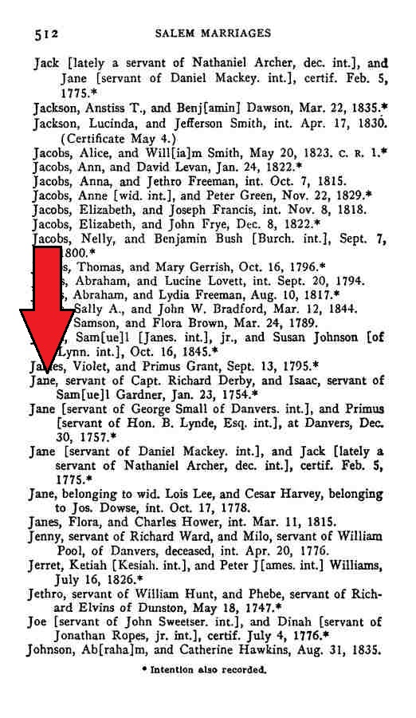

Image Source
Early Vital Records of Massachusetts, From 1600 to 1850. www.ma-vitalrecords.org

Graphic Organizer & Guiding Questions

Opening Question – Answer before reading the documents and background information.
How do you think Salem colonists viewed slavery?

Explain your opinion.

Graphic Organizer
 | Document A  Work for You at Your Distilling House | Document B  Marriage of Jane and Isaac
#1
When and where was this document written?
#2
What type of document is this?

What is its purpose?

 | Document A  Work for You at Your Distilling House | Document B  Marriage of Jane and Isaac
#3
What evidence is there of enslaved people?

What do we know about them?

(Age, gender, where they’re from, heritage, etc.)

Answer using evidence from the document.

#4
Interpret the evidence

How did slavery affect their lives?

(Relationships, labor, where they lived, etc.)

Use previous question and background info to answer.

#5
How does Richard Derby participate in the system of slavery?

 | Document A  Work for You at Your Distilling House | Document B  Marriage of Jane and Isaac
#6
Interpret the evidence

How did this happen?

What choices did Derby make?

What might have been his reasons for making them?
#7
What questions do you have about this document?

(People, details, etc.)

List at least two for each document.

Closing Question
How do you think Salem colonists viewed slavery?

Use the background info, evidence from the documents, and answers from the graphic organizer to explain your opinion.

